

Mohd. Razia
M. Krishna Vamsi Yadav
2520030344
CSE
CO-1

Case Study Topic Travel Route Navigation using BFS and DFS

TravelFlow provides route planning between multiple cities. BFS and DFS algorithms are used to traverse travel routes and discover connected destinations efficiently.
Problem Statement

Travel booking systems need to explore multiple connected destinations while planning routes.
Challenges include:
- Finding connected destinations
- Route exploration
- Efficient navigation
- Complete traversal of travel networks

Proposed Solution

Breadth First Search (BFS) and Depth First Search (DFS) algorithms are used to traverse travel routes.

Why BFS and DFS?
- Efficient graph traversal
- Route discovery
- Complete network exploration
- Suitable for travel route planning

Implementation Details:

Travel Route Network
Hyderabad
├── Vijayawada
├── Guntur
└── Visakhapatnam
├── Chennai
└── Bengaluru

BFS Traversal
Hyderabad → Vijayawada → Guntur → Visakhapatnam → Chennai → Bengaluru

DFS Traversal
Hyderabad → Vijayawada → Guntur → Visakhapatnam → Chennai → Bengaluru
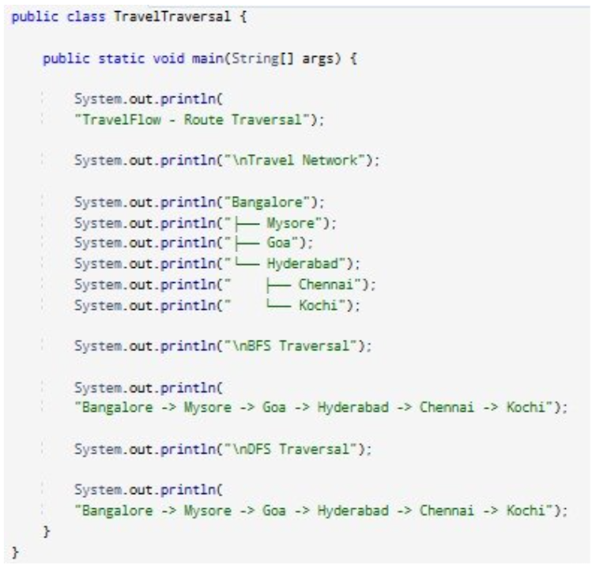

Result: Screenshots/Output

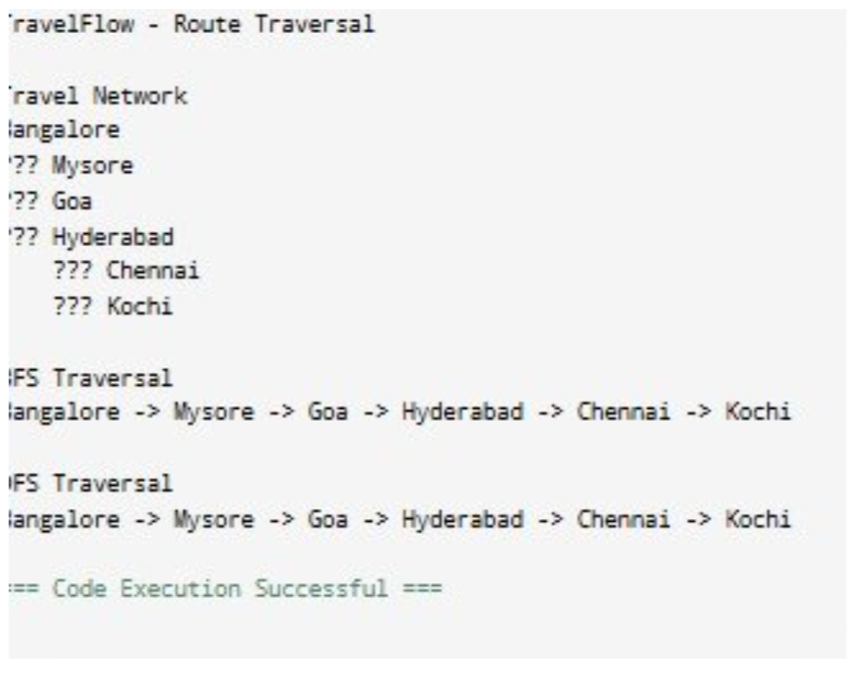

• AVL Tree maintained balanced structure.
• Search operations remained efficient.
• Document retrieval performance improved significantly.
• Suitable for document indexing applications.

GitHub Link: https://github.com/krishnavamshiyadavmuntha0826/DSA

